Lab No-03
Name of the Lab : Threads on Operating System
Name: Arafat Islam
ID:IT-17008

Objective

How to learn about Thread , Threads type and Threads
Implementation.

Threads on Operating System

1. What is Thread ?

Ans :
A thread is a path of execution within a process . A process can contain multiple threads.
In most modern operating systems, a thread exists within a process - that is, a single process may contain multiple threads.

2. Types of Threads :

Threads are implemented in following two ways −

- User Level Threads
- Kernel Level

- User Level thread (ULT) –
Is implemented in the user level library, they are not created using the system calls. Thread switching does not need to call OS and to cause interrupt to Kernel. Kernel doesn’t know about the user level thread and manages them as if they were single-threaded processes.
Advantages of ULT –
  - Can be implemented on an OS that does’t support multithreading.
  - Simple representation since thread has only program counter, register set, stack space.
  - Simple to create since no intervention of kernel.
  - Thread switching is fast since no OS calls need to be made.
Disadvantages of ULT –
  - No or less co-ordination among the threads and Kernel.
  - If one thread causes a page fault, the entire process blocks.
2.Kernel Level Thread (KLT) –
In this case, the thread management kernel is not aware of the existence of threads. The thread library contains code for creating and destroying threads, for passing message and data between threads, for scheduling thread execution and for saving and restoring thread contexts. The application starts with a single thread.
Advantages of KLT –
  - Since kernel has full knowledge about the threads in the system, scheduler may decide to give more time to processes having large number of threads.
  - Good for applications that frequently block.
Disadvantages of KLT –
  - Slow and inefficient.
  - It requires thread control block so it is an overhead.

- Question : Implementation of threads.
- Answer :

1.Threads Implementation in User Space
- In this model of implementing the threads package completely in user space, the kernel don't know anything about them.
- The advantage of implementing threads package in user space is that a user-level threads package can be implemented on an OS (Operating System) that doesn't support threads.
- All of these implementations have the same general structure as illustrated in the figure given below.

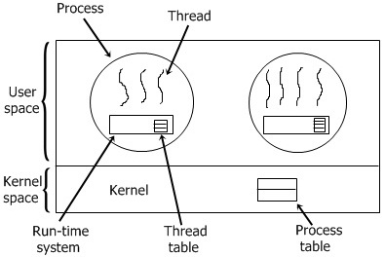

2.Threads implementation in user space :
In this method of implementing the threads package entirely in the kernel, no any run-time system is need in each as illustrated in the figure given below.

In this, there is no any thread table in each process. But to keep track of all the threads in the system, the kernel has the thread table .Whenever a thread wants to create a new thread or destroy an existing thread, then it makes a kernel call, which does the creation or destruction just by updating the kernel thread table .The thread table of the kernel holds each registers, state, and some other useful information of the thread . In this method of implementation model, the threads package completely in the kernel. There is no need for any runtime system. To maintain the record of all threads in the system a kernel has a thread table.

